
KSIT Bangalore
DEPARTMENT OF COMPUTER SCIENCE AND ENGINEERING
ASSIGNMENT QUESTIONS
Academic Year | 2020-2021
Batch | 2018-2022
Year/Semester/section | 2020/V A & B
Subject Code-Title | 18CS54 – AUTOMATA THEORY & COMPUTABILITY
Name of the Instructor | Mr. K Venkata Rao | Dept | CSE

Assignment No: 1 Total marks : 10
Date of Issue:01-10-2020 Date of Submission:06-10-2020
Sl.No | Assignment Questions | K  Level | CO | Marks
 | Define the following terms:  a)Alphabet b) Power of an alphabet c) Language d) strings | Applying (K3) | CO1 | 1
 | Draw a DFA to accept strings of a’s and b’s having odd no. of a’s and even no. of b’s. | Applying (K3) | CO1 | 1
 | Obtain an NFA to accept strings of a’s and b’s ending with ‘ab’ or ba’. From this NFA Obtain an Equivalent DFA. | Applying (K3) | CO1 | 1
 | Obtain DFA for the following ε- NFA.  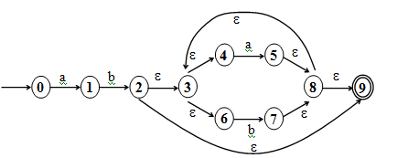 | Applying (K3) | CO1 | 1
 | Write differences between DFA, NFA and ε-NFA. | Applying (K3) | CO1 | 1
 | Make use of minDFSM to minimize M.Let M be the following DFSM. 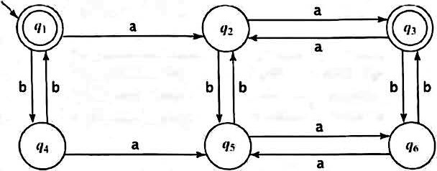  ( OR )  Construct minimum state equivalent automata for the following DFA.  0 1  A B A  B A C  C D B  *D D A  E D F  F G E  G F G  H G D | Applying (K3) | CO1 | 1
 | Obtain regular expressions for the following languages on ∑ = {a, b, c}.  - all strings containing exactly one a  - all strings containing no more than three a’s  - all strings that contain at least one occurrence of each symbol in ∑ | Applying (K3) | CO2 | 1
 | Obtain a Regular expression for the language.  - L={a^{n}b^{m} | n+m is even}  - L={a^{n}b^{m} |m ≥ 1, n ≥ 1 and nm ≥0 } | Applying (K3) | CO2 | 1
 | Define a regular expression. Find regular expression for the following languages on{ a, b }: i) L={a^{2n}b^{2m} | n ≥0 and m ≥0  ii)L={ w : |w | mod 3 = 0}, w ∈ { a, b }* | Applying (K3) | CO2 | 1
 | Obtain a Regular expression for the following languages  - To accept strings of a’s & b’s such that every block of four consecutive symbols contains at least two a’s.  - To accept strings of a’s & b’s whose length is either even or multiples of 3 or both. | Applying (K3) | CO2 | 1

Signature of Course Incharge Signature of HOD-CSE

